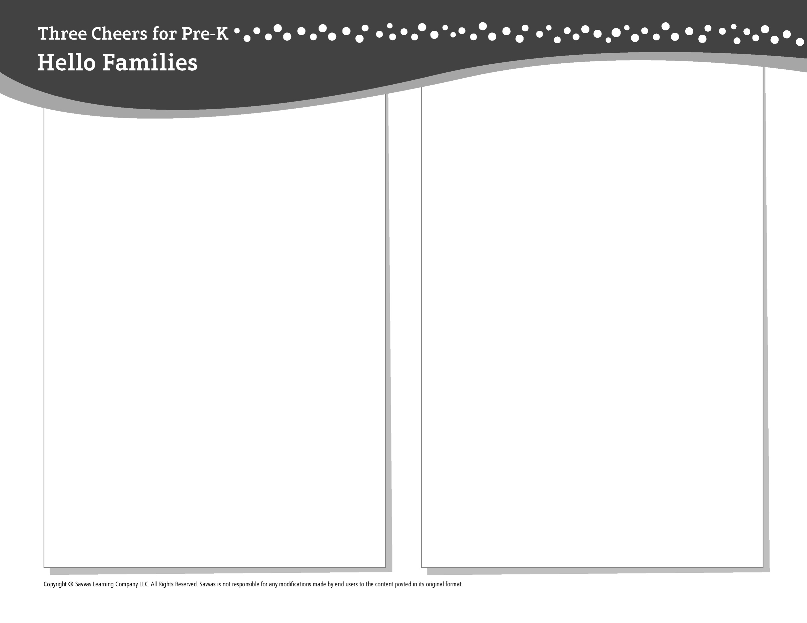THEME 7 • WEEK 4

This week, I am learning about…

All kinds of vehicles

Social and Emotional Learning

I can speak clearly to tell about what I know!

Alphabet Knowledge

Aa, Bb, Cc, Dd, Ff, Gg, I i, Jj, Ll, Mm, Nn, O o, Pp, Qq, Rr, Ss, Tt, U u, Ww

Social Studies

Making and using maps

Science

Discovering how magnets work

Math

Shapes stay the same when you flip or move them.

Literacy

We read these books:

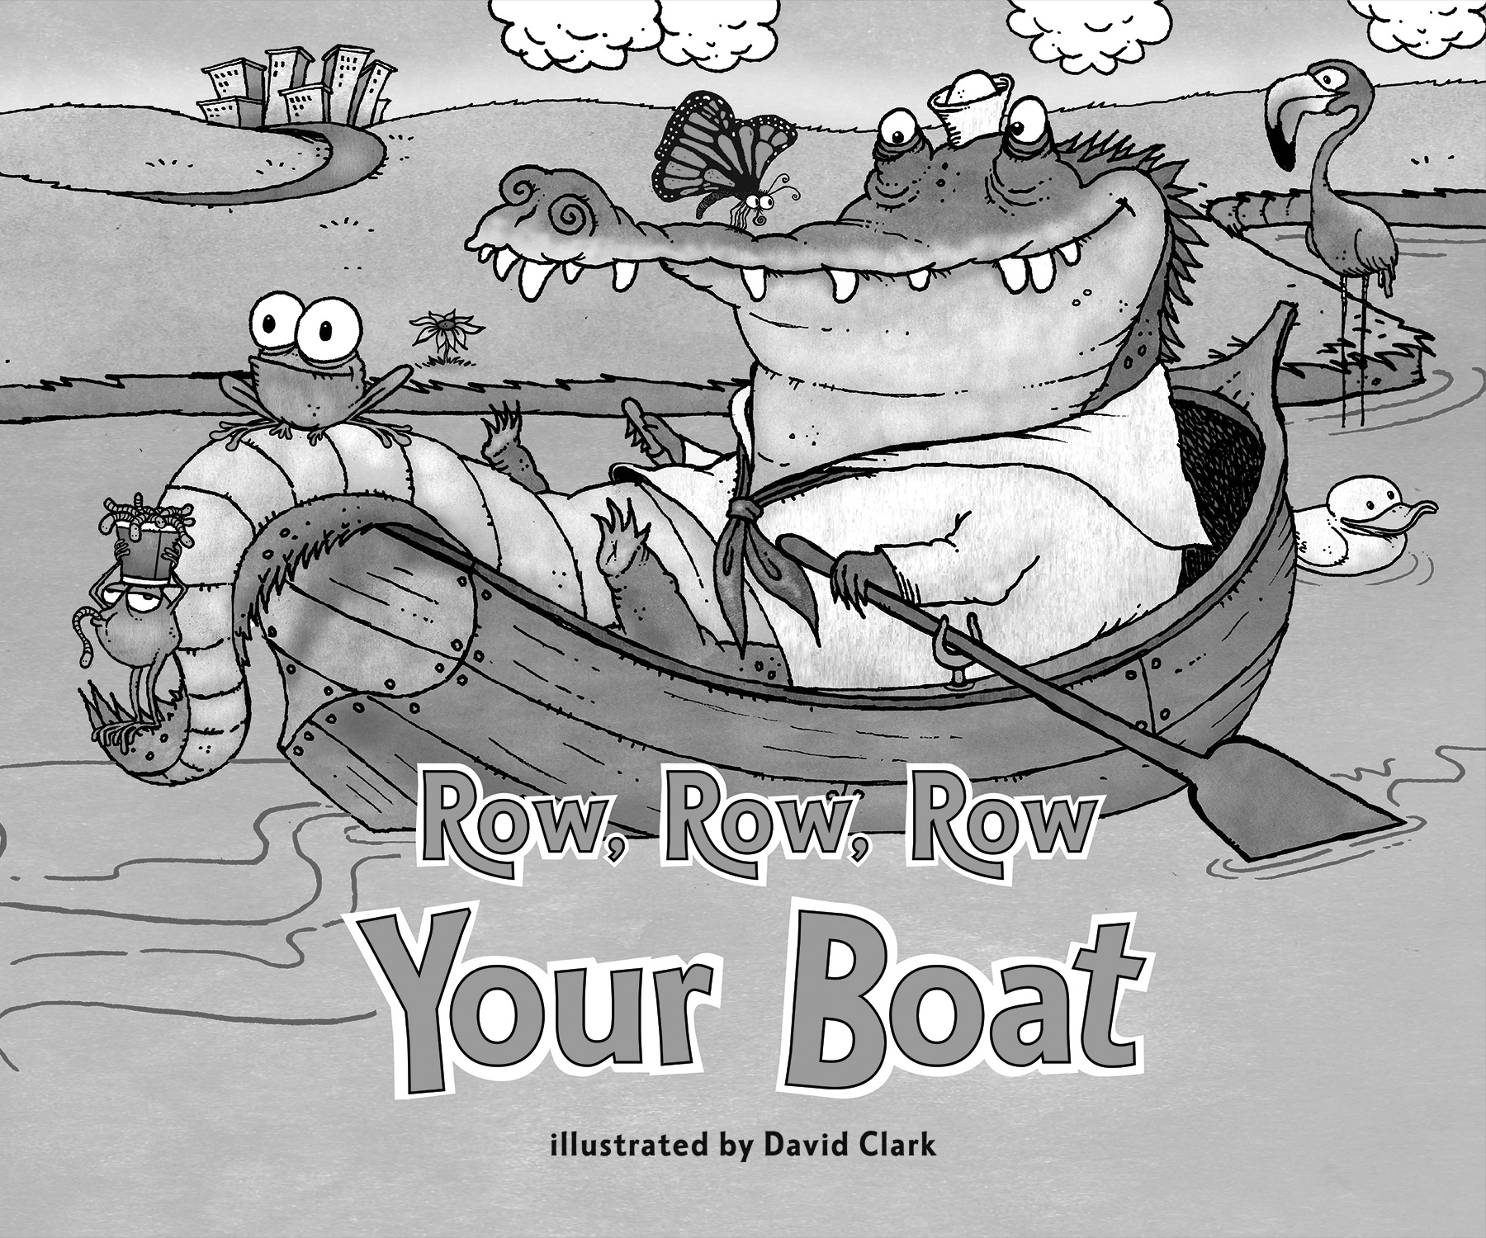 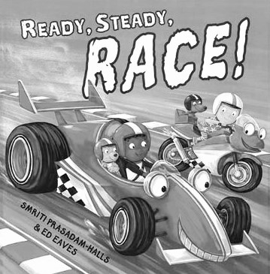 

*Row, Row, Row Your Boat* (Savvas Learning Company)

*Ready, Steady, Race!* (Hodder Children’s Books)

This week, try this!

DO

• Cut shapes out of paper. Flip them and move them. Do they change shape?

ASK

• What can you tell me about your day today? Why is it important to speak clearly?

• Where have you seen maps? How can a map help you find places?

READ

• Explore **Unite for Literacy:** *This Is My Town.*   
Then ask: What places in this book could you find on a map?

• Look for books about magnets, such as *Magnets Push, Magnets Pull* (Holiday House) by David Adler.

PLAY

• Hunt for the following letters as you look at a map:   
*A, B, C, D, F, G, I, J, L, M, N, O, P, Q, R, S, T, U, W*.

• Access games on **SavvasRealize.com.**

CONNECT

• Go to **SavvasRealize.com** to find activities that work for your family.

• Comments or questions? Please contact me: