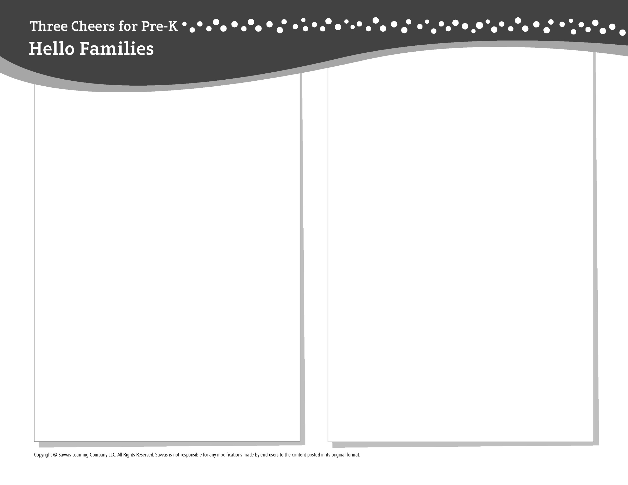
THEME 1 • WEEK 1

This week, I am learning about…

What my school is like

Social and Emotional Learning
I can follow rules and routines!

Alphabet Knowledge
Introduce the alphabet

Fine Arts
Using art supplies and tools

Science
Looking at objects and telling about them

Math
Counting to 5

Literacy
We read these books:
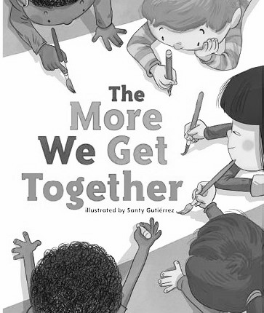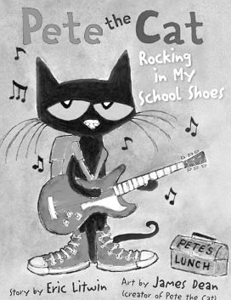
The More We Get Together (Savvas Learning Company)
Pete the Cat (HarperCollins)
This week, try this!

DO
• Count fingers on one hand and then the other. Count the toes on each foot.

ASK
• Point to an item. Ask: What color is this? How does it feel? What else can we tell about this?
• What rules do we have at home? What routines do we follow?

READ
• Explore Unite for Literacy: Look! Then ask: What do you see when you look closely at the dandelion on the book’s cover?
• Look for books about preschool, such as Ming Goes to School (Sky Pony) by Deirdre Sullivan.

PLAY
• Write down the names of family members and friends and find the A’s in their names.
• Access games on SavvasRealize.com.

CONNECT
• Go to SavvasRealize.com to find activities that work for your family.
• Comments or questions? Please contact me:

