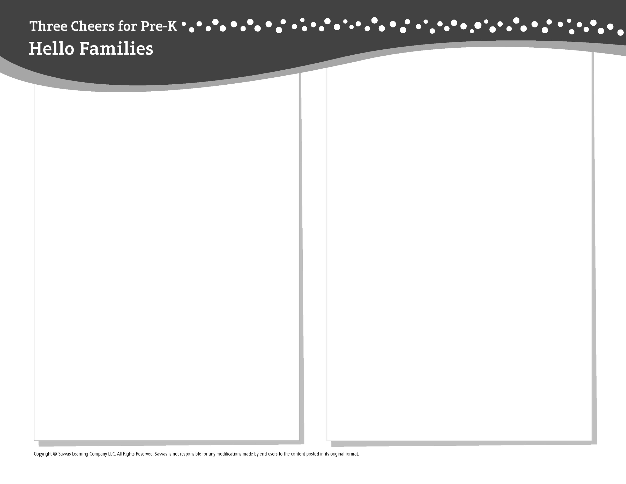
THEME 1 • WEEK 3

This week, I am learning about…

Feeling safe and belonging

Social and Emotional Learning
Being safe at school makes me feel calm.

Alphabet Knowledge
Mm, SS

Science
We can measure things to see how short, tall, or long they are.

Math
Counting to 5

Technology
All about devices, programs, and apps

Literacy
We read these books:
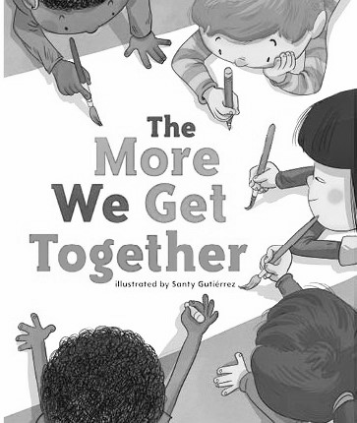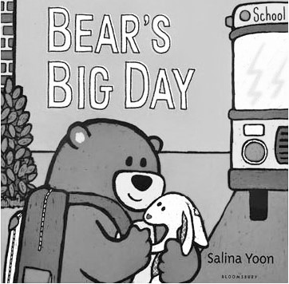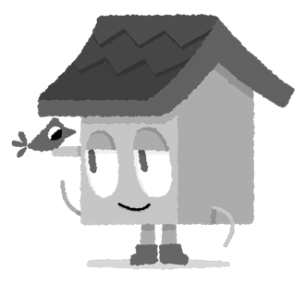
The More We Get Together (Savvas Learning Company)
Bear’s Big Day (Bloomsbury USA)
This week, try this!

DO
• Together, arrange blocks or other toys in rows of 1, 2, 3, 4, and 5 objects.

ASK
• Point to two objects. Ask: Which one is longer? Which one is shorter?
• What helps you feel calm and safe at school? What helps you feel calm and safe at home?

READ
• Explore Unite for Literacy: Teach Your Computer. Then ask: How is a computer like a cell phone?
• Look for books about feelings, such as Llama Llama Misses Mama (Viking) by Anna Dewdney.

PLAY
• Think of foods that start with the letters M and S. Find pictures of them in magazines or books.
• Access games on SavvasRealize.com.

CONNECT
• Go to SavvasRealize.com to find activities that work for your family.
• Comments or questions? Please contact me:

