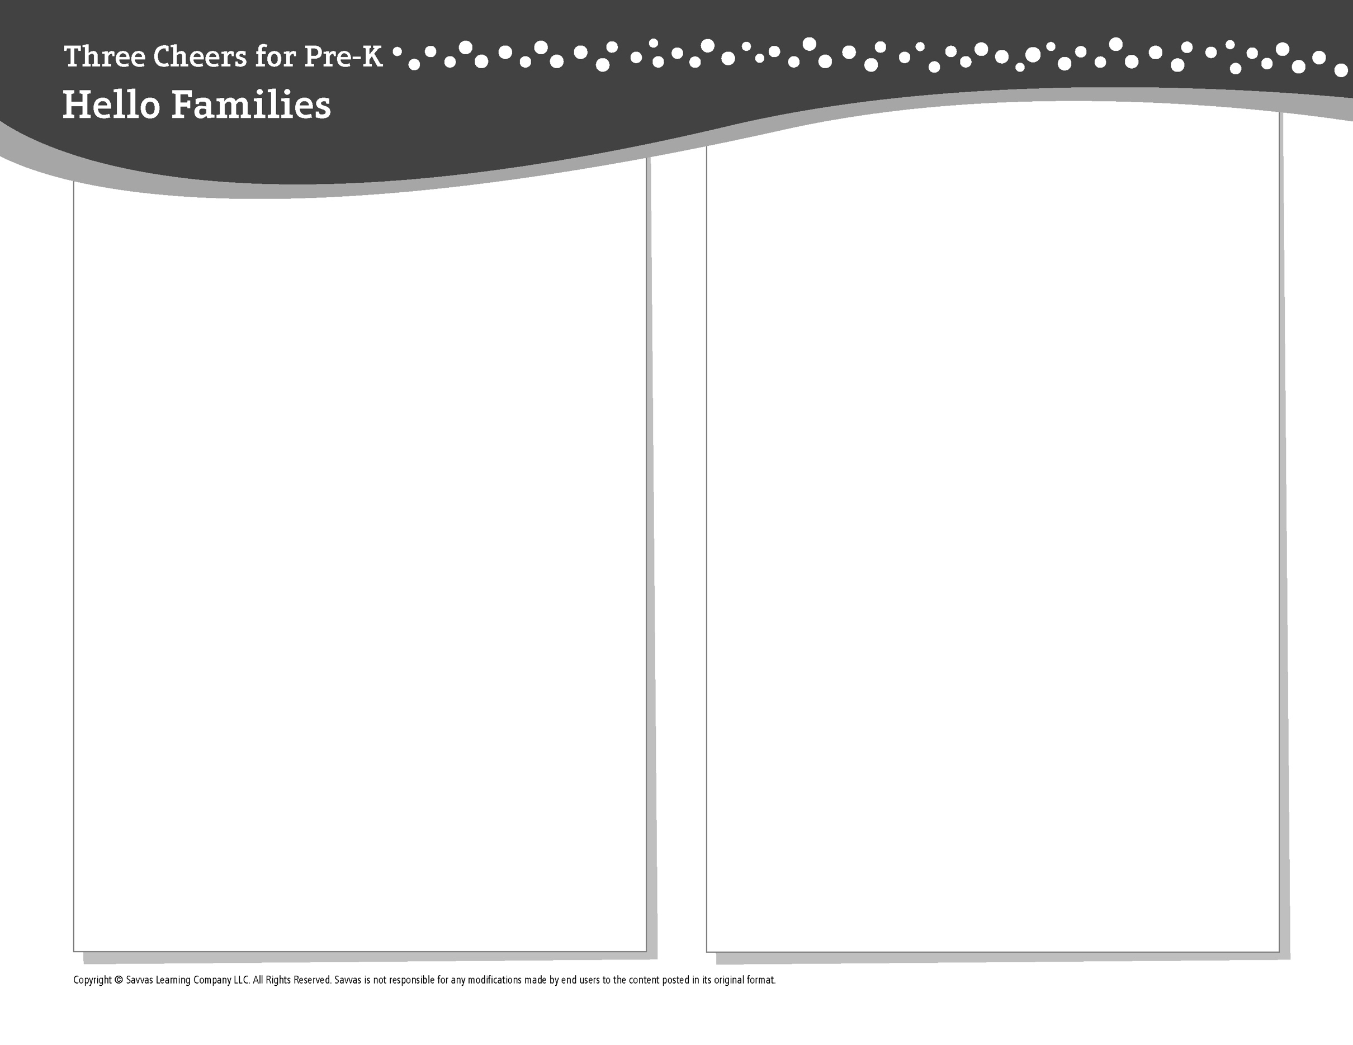
THEME 1 • WEEK 2

This week, I am learning about…

Classroom rules and routines

Social and Emotional Learning
I can tell how I feel and understand how others
feel, too.

Alphabet Knowledge
Ss

Social Studies
How am I like other children and how I am different?

Science
Some objects are heavy; others are light.

Math
Counting to 5

Literacy
We read these books:
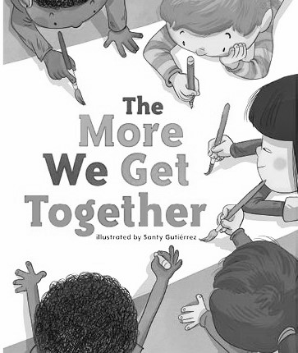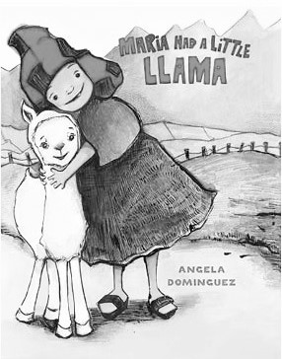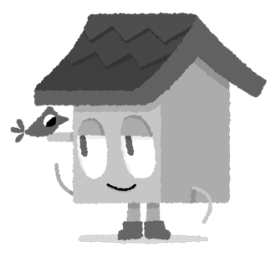
The More We Get Together (Savvas Learning Company)
Maria Had a Little Llama (Henry Holt and Co.)
This week, try this!

DO
• Together, pick up objects and talk about which ones are heavy and which ones are light.

ASK
• Can you tell me about something that made you happy at school today?
• How are you the same as other children at school? How are you different?

READ
• Explore Unite for Literacy: Fair for Everyone.
Then ask: How do you share toys at school?
• Look for books about counting, such as One Duck Stuck (Candlewick) by Phyllis Root.

PLAY
• Brainstorm a list of animals that start with the letter A and a list of animals that start with the letter S.
• Access games on SavvasRealize.com.

CONNECT
• Go to SavvasRealize.com to find activities that work for your family.
• Comments or questions? Please contact me:

