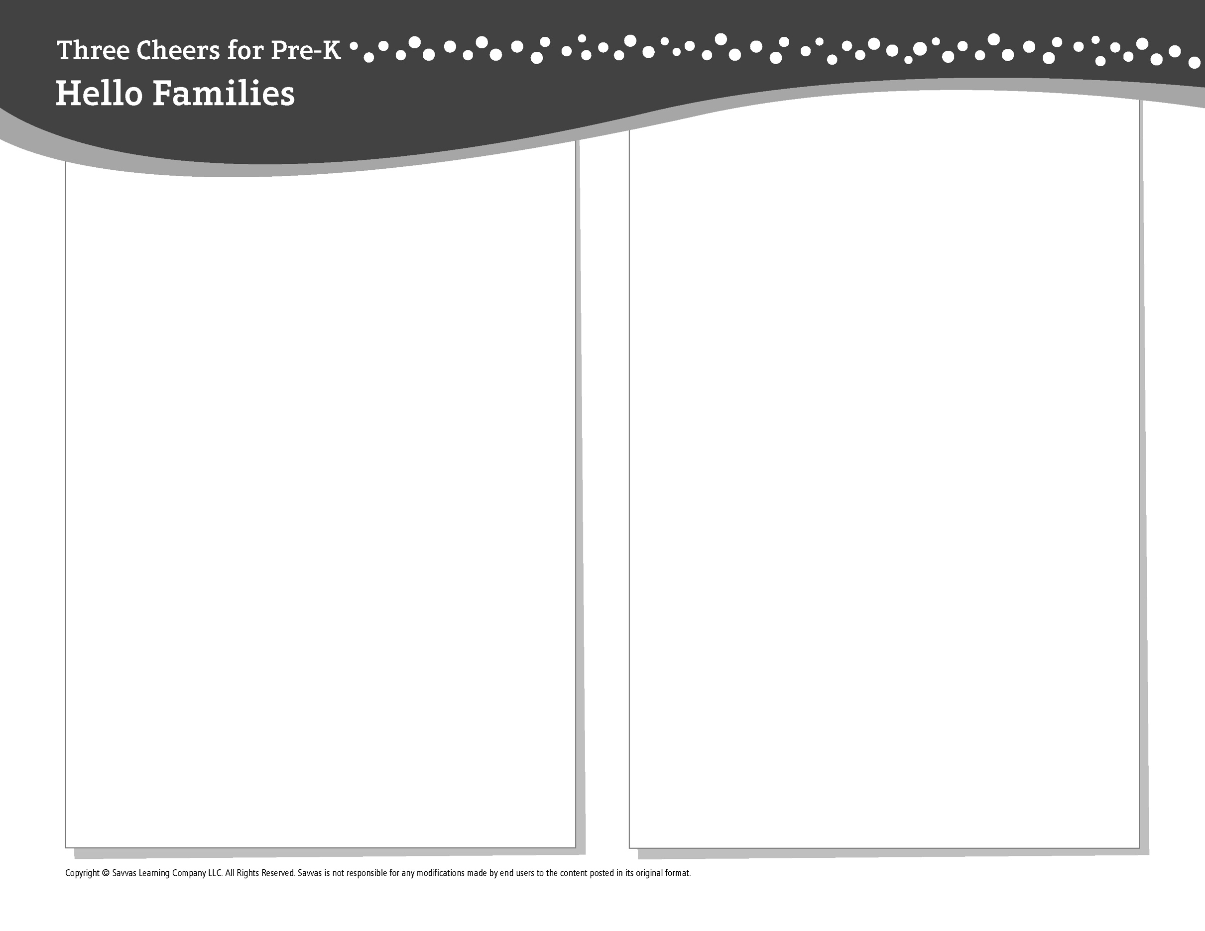
THEME 1 • WEEK 4

This week, I am learning about…

How my school compares to schools around the world

Social and Emotional Learning
I can celebrate my school and my learning!

Alphabet Knowledge
Mm, Ss

Social Studies
People in a community are alike in some ways and different in others.

Science
Different things have different textures.

Math
Counting to 5 and writing numerals 1, 2, 3, 4, 5

Literacy
We read these books:
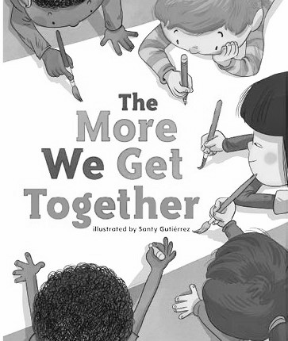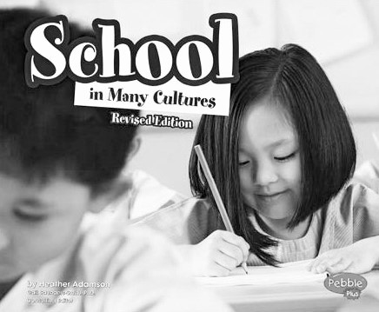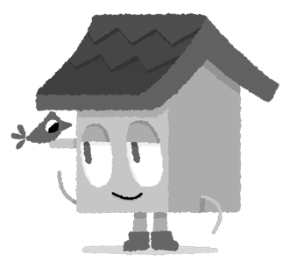
The More We Get Together (Savvas Learning Company)
School in Many Cultures (Capstone Press)
This week, try this!

DO
• Point out the numerals 1, 2, 3, 4, and 5 on signs, in address numbers on buildings, and in the store.

ASK
• What did you like learning about in school today?
• Provide objects with different textures. Ask: How does this feel? Which ones are smooth? soft? rough? hard?

READ
• Explore Unite for Literacy: Which Pet Will You Get? Then ask: What does each pet feel like?
• Look for books about schools in other countries, such as School Days Around the World (Kids Can Press) by Margriet Ruurs.

PLAY
• Look at a map of the United States. Find the states that start with the letters M and S.
• Access games on SavvasRealize.com.

CONNECT
• Go to SavvasRealize.com to find activities that work for your family.
• Comments or questions? Please contact me:

