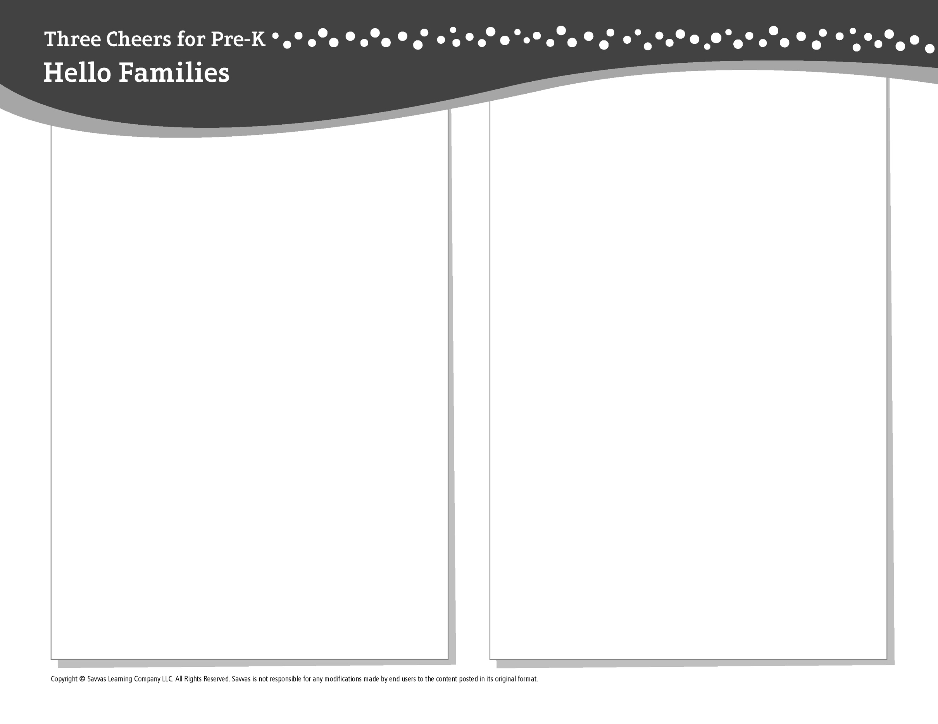THEME 7 • WEEK 1

This week, I am learning about…

Types of transportation

Social and Emotional Learning

I can behave in ways that show respect for others.

Alphabet Knowledge

*Qq*

Social Studies

Transportation across land and sea

Science

All about light, heat, and electricity

Math

Identifying patterns

Literacy

We read these books:

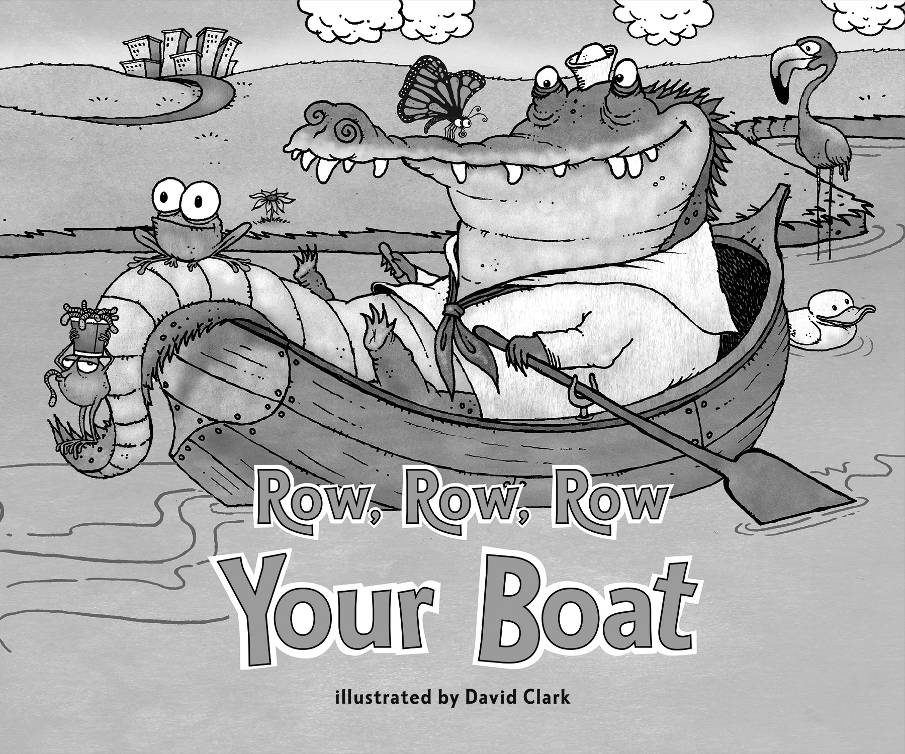 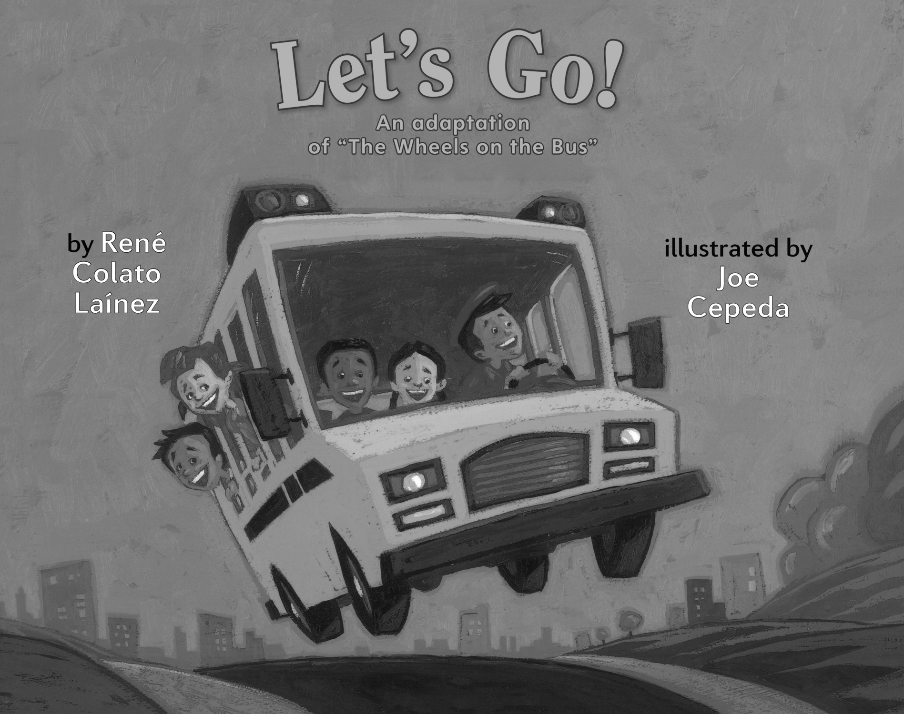 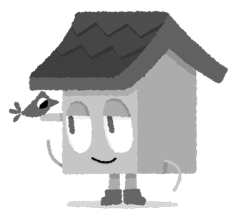

*Row, Row, Row Your Boat* (Savvas Learning Company)

*Let’s Go! An Adaptation of “The Wheels on the Bus”* (Holiday House)

This week, try this!

DO

• Look at clothes in a closet or drawer to find ones with patterns and describe the patterns.

ASK

• What did you do today that showed respect for someone else? How do people show respect for you?

• What things in this room make light? Which things need electricity to work?

READ

• Explore **Unite for Literacy:** *Trains, Planes and Boats*. Then ask: How would you like to travel?

• Look for books about light, such as *Light Is* *All Around Us* (HarperCollins) by Wendy Pfeffer.

PLAY

• Hunt for *Q’*s in a magazine or newspaper.

• Access games on **SavvasRealize.com.**

CONNECT

• Go to **SavvasRealize.com** to find activities that work for your family.

• Comments or questions? Please contact me: