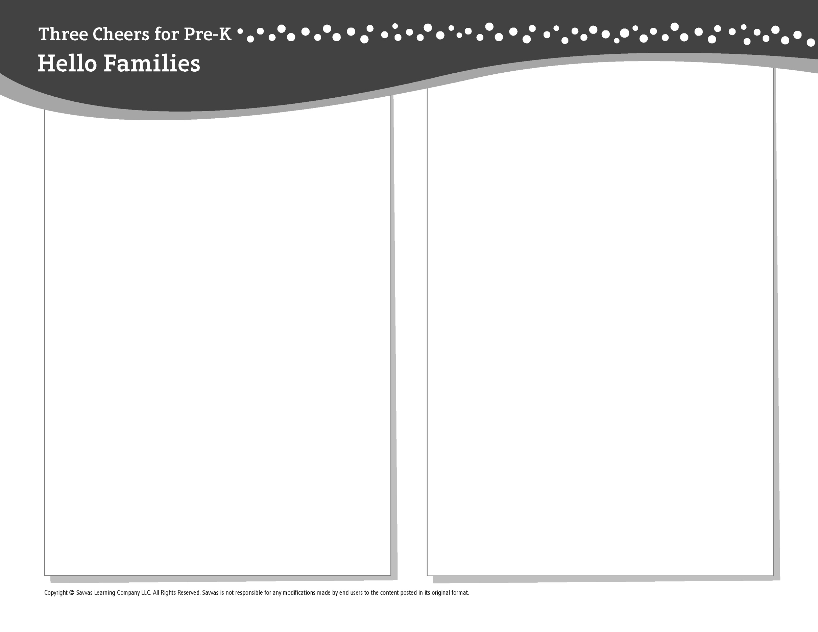THEME 7 • WEEK 3

This week, I am learning about…

Trucks and planes

Social and Emotional Learning

I follow rules and directions in my classroom.

Alphabet Knowledge

*Ww*

Technology

Finding information on digital devices

Science

Pushing and pulling helps us move things.

Math

Using spheres, cubes, cones, and cylinders

Literacy

We read these books:

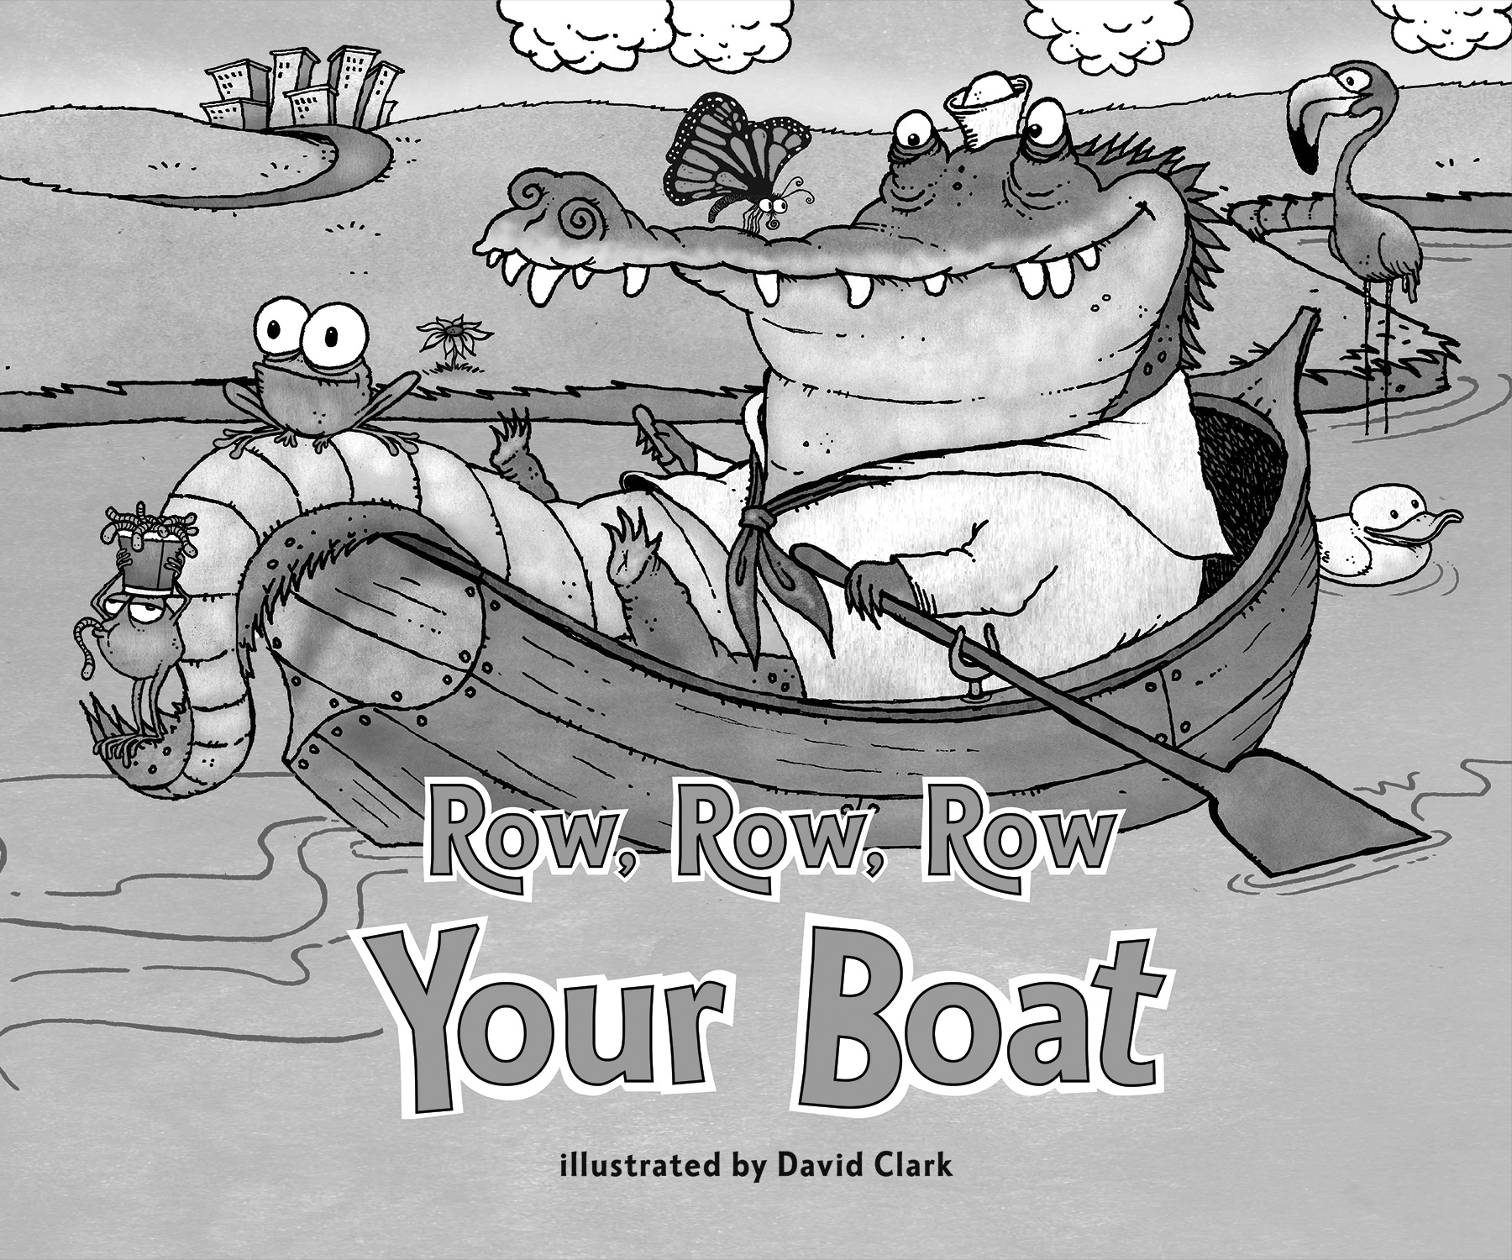 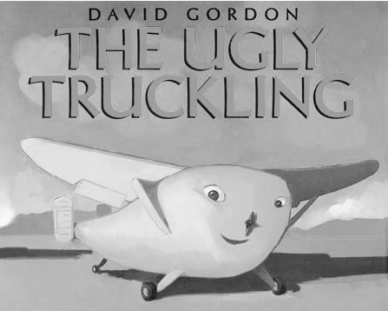 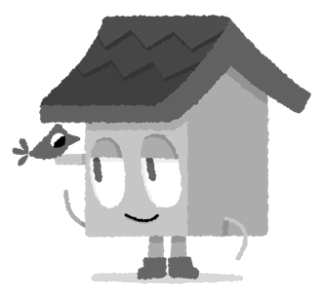

*Row, Row, Row Your Boat* (Savvas Learning Company)

*The Ugly Truckling* (HarperCollins)

This week, try this!

DO

• Point out the letter *W* on packages in the kitchen.

ASK

• What rules did you follow today? How does following rules help us show respect for others?

• What kind of information would you like to find using a digital device?

READ

• Explore **Unite for Literacy:** *How Many Wheels?*   
Then ask: How would you use pushing to move things? What kinds of things roll when you pull them?

• Look for books about shapes, such as *Cubes, Cones, Cylinders, and Spheres* (Greenwillow) by Tana Hoban.

PLAY

• Make up a list of rules for family members to follow when they are at home.

• Access games on **SavvasRealize.com.**

CONNECT

• Go to **SavvasRealize.com** to find activities that work for your family.

• Comments or questions? Please contact me: